**DAILY ONLINE ACTIVITIES SUMMARY**

|  |  |  |  |  |  |  |  |  |
| --- | --- | --- | --- | --- | --- | --- | --- | --- |
| **Date:** | **9-06-2020** | | | | | **Name:** | **Javahar.S.Goutham** | |
| **Sem & Sec** | **7th B sec** | | | | | **USN:** | **4AL16cs132** | |
| **Online Test Summary** | | | | | | | | |
| **Subject** | | **Big data Analysis** | | | | | | |
| **Max. Marks** | | **30** | | **Score** | | | **21** | |
| **Certification Course Summary** | | | | | | | | |
| **Course** | **Ethical hacking**  **rpa** | | | | | | | |
| **Certificate Provider** | | | **Great learning**  **Guvi** | | **Duration** | | | 1h**rs** |
| **Coding Challenges** | | | | | | | | |
| **Problem Statement**: 1. Write a Python program to implement Perfect Sum problem.  2. Write a Java Program to print smallest and biggest possible palindrome word in a given string.  3. Python Program to count even and odd numbers.  4. Write a Java Program to remove all white spaces from a string without using replace().  5. Write a C Program to rotate the matrix by K times. | | | | | | | | |
| **Status: YES, Completed all Programs.** | | | | | | | | |
| **Uploaded the report in Github** | | | | | **YES** | | | |
| **If yes Repository name** | | | | | <https://github.com/alvas-education-foundation/Dhanya-bhat-4AL17CS027> | | | |

Online Test Details: (Attach the snapshot and briefly write the report for the same)

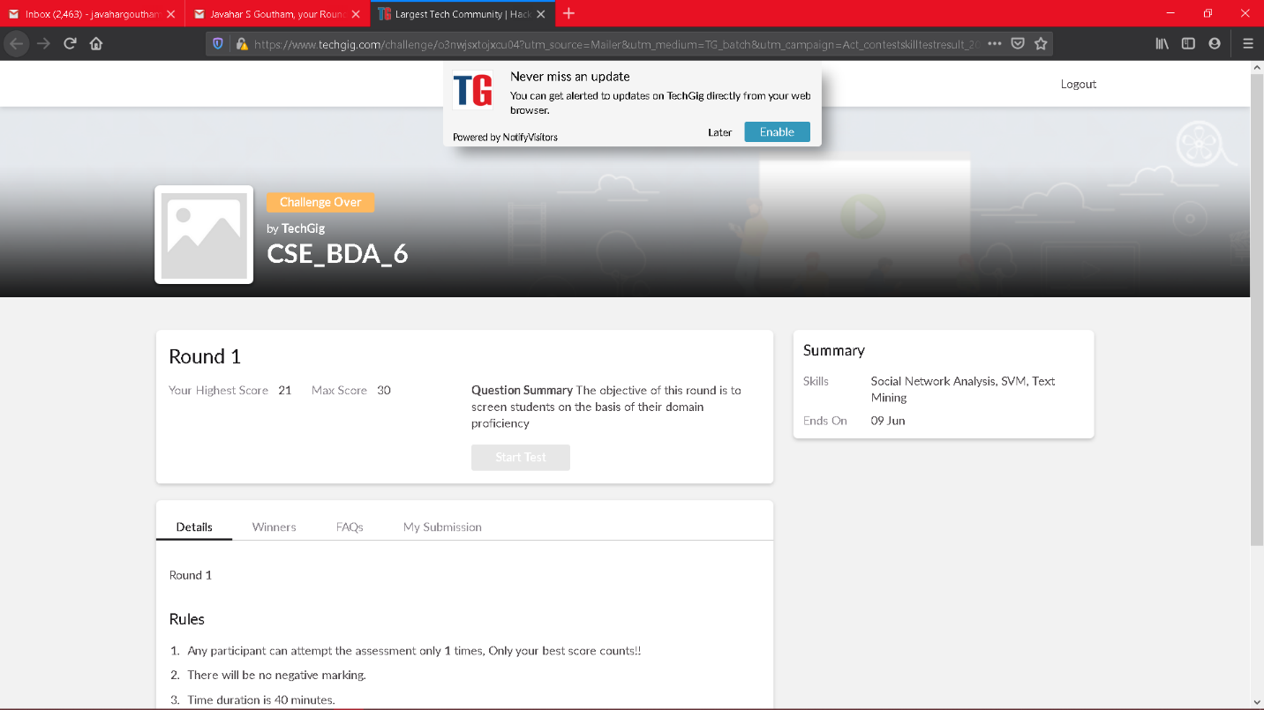

Scored 21 out of 30 in BDA test

Certification Course Details: (Attach the snapshot and briefly write the report for the same)

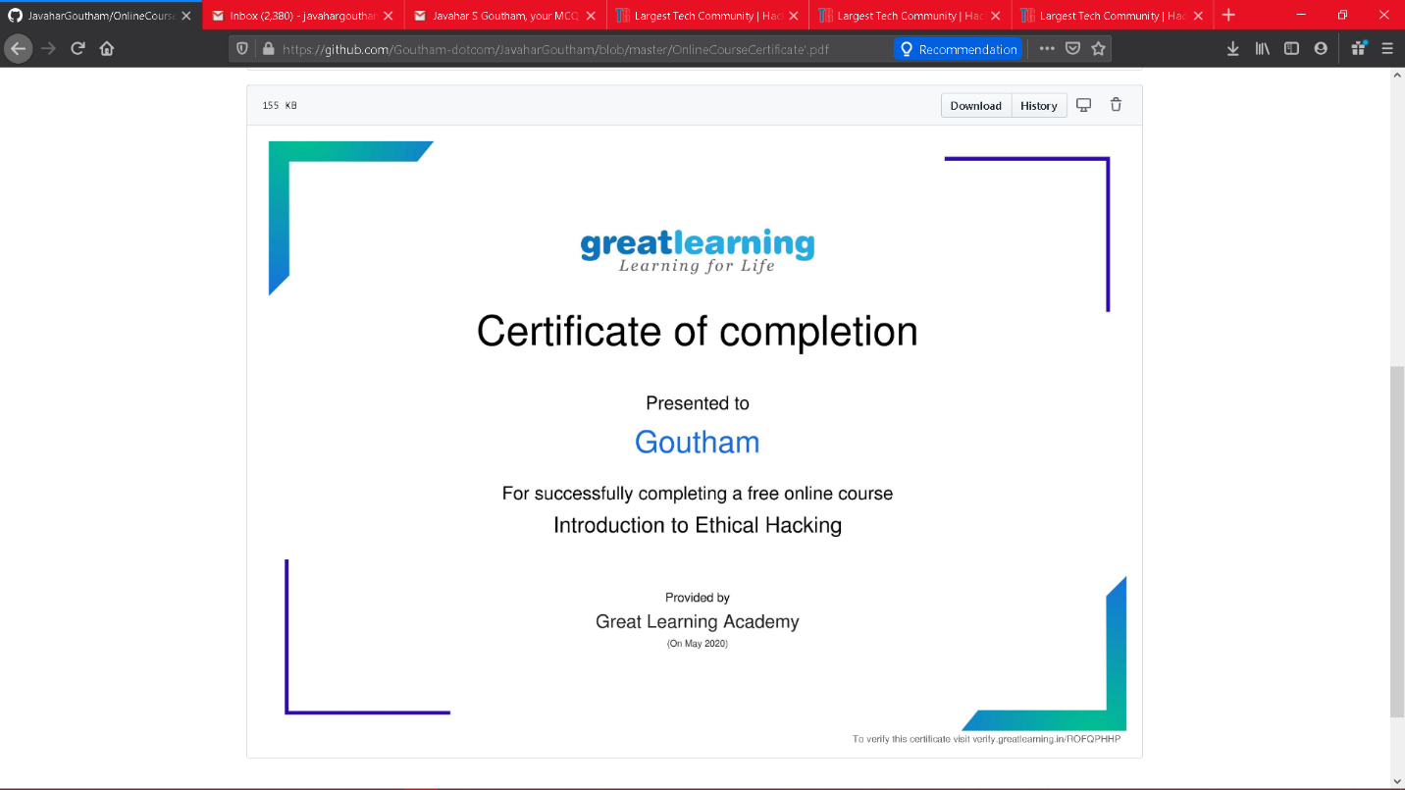

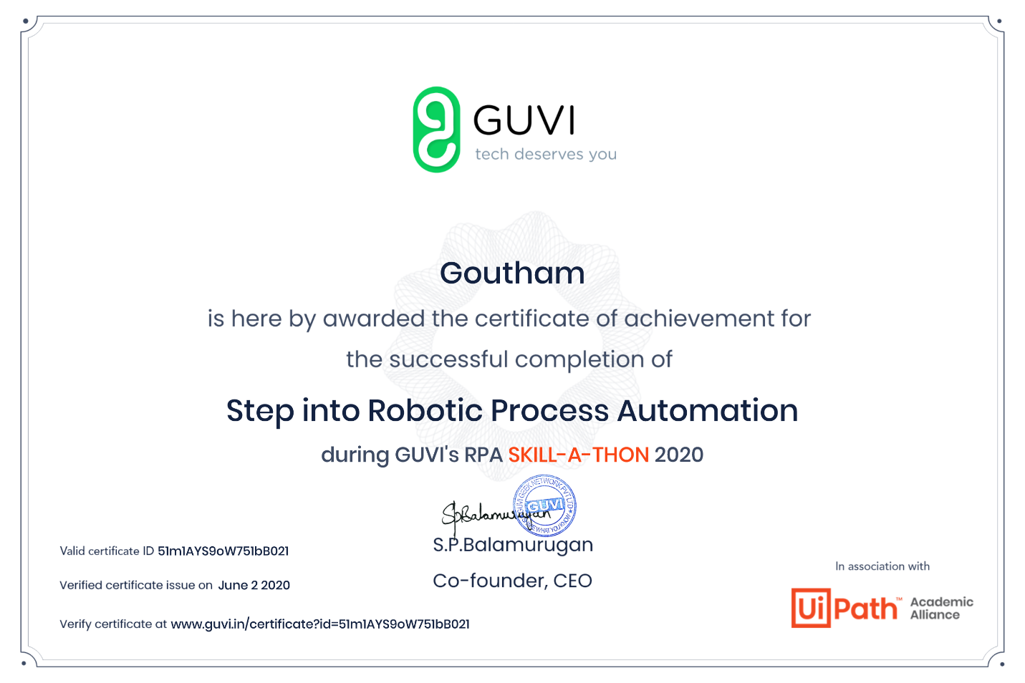

Coding Challenges Details: (Attach the snapshot and briefly write the report for the same)

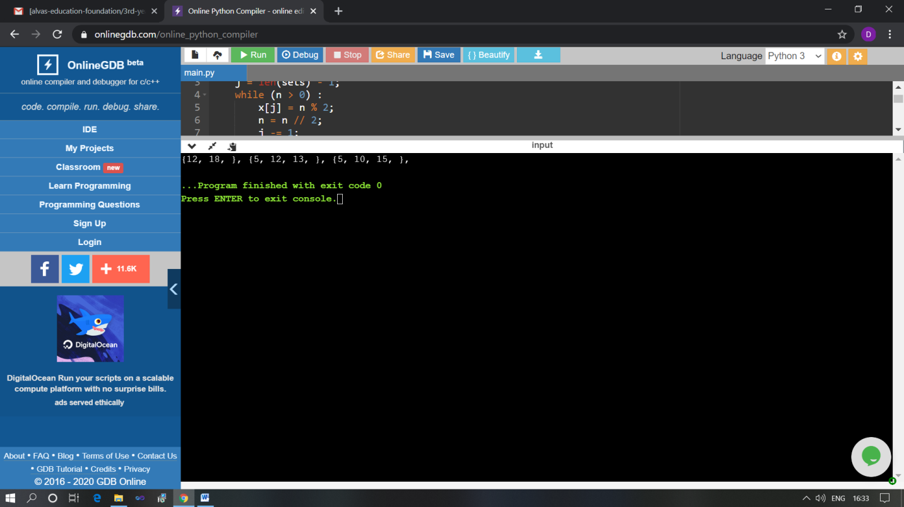

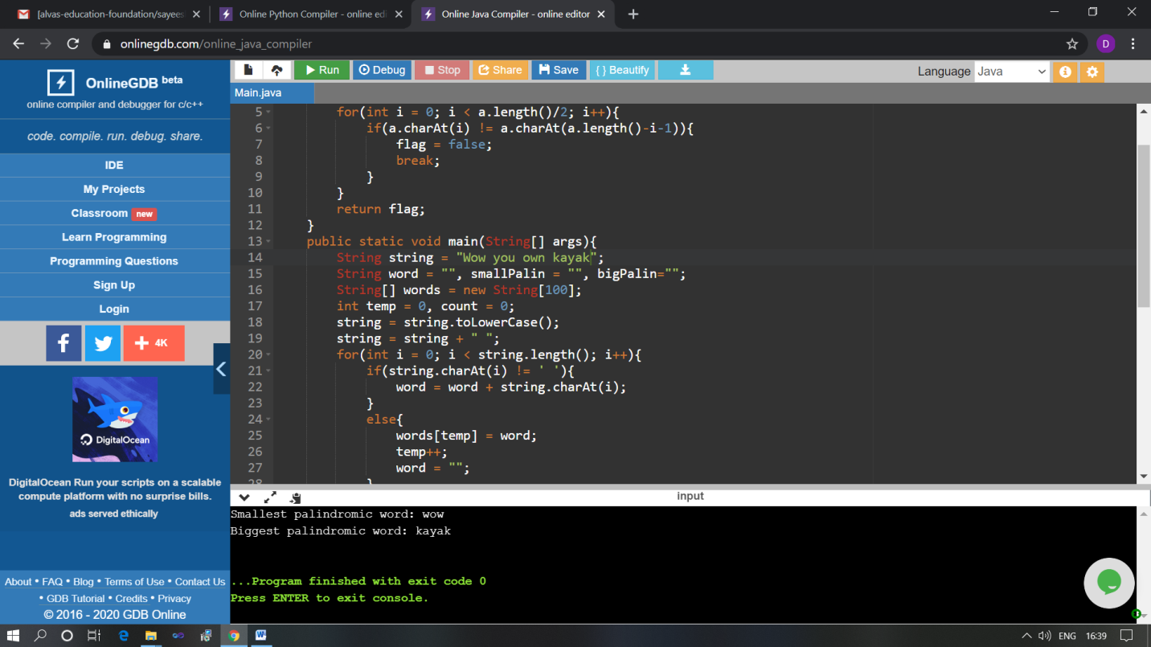

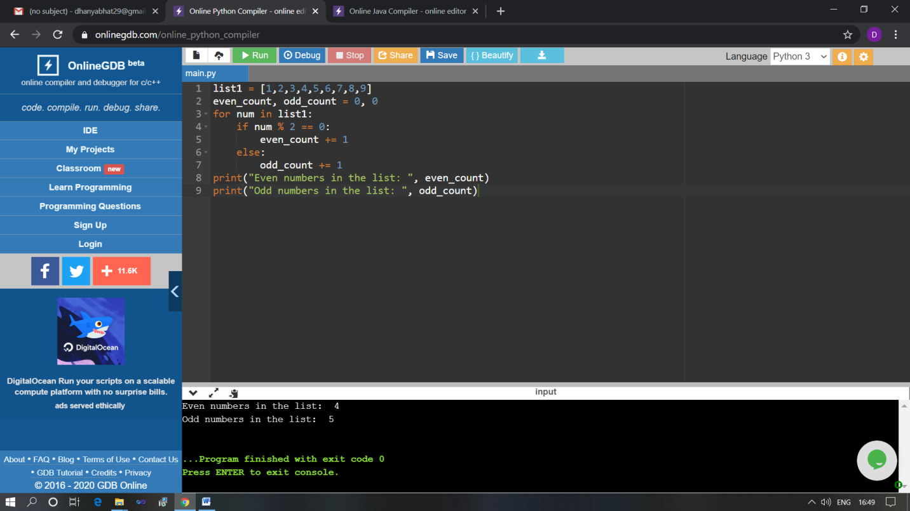

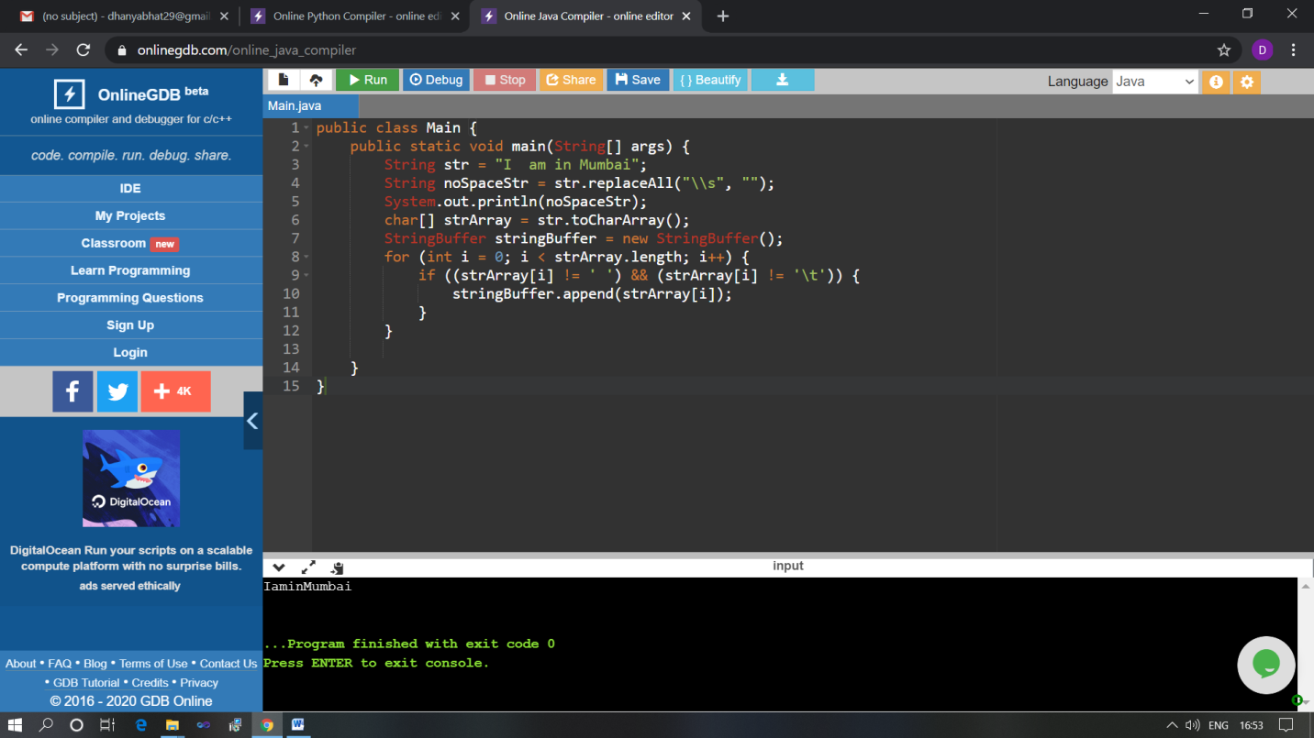

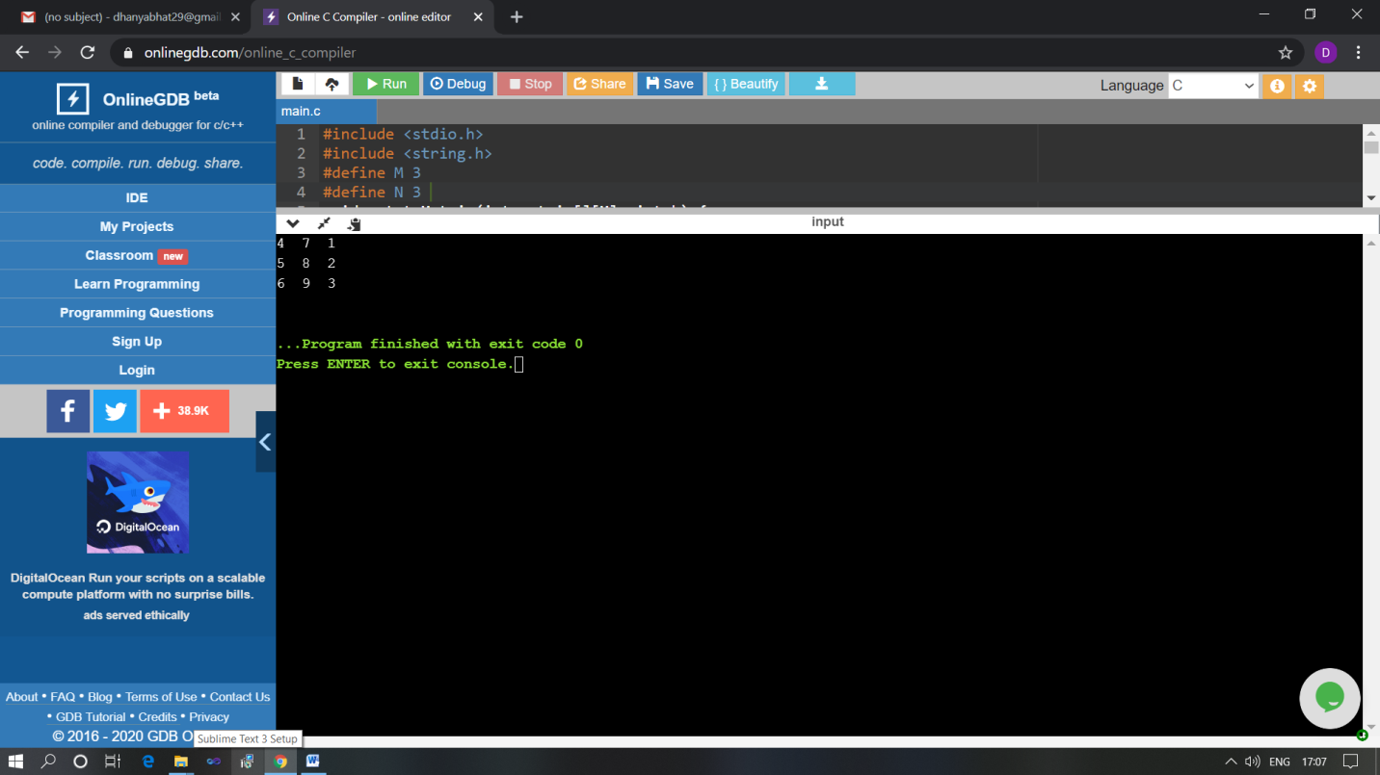

The above Programs were written and executed and the output of the same is displayed above. The code for those 5 programs have been uploaded to the github repository and the link to the same is provided on the form.